**Archery Madness**

**Production Plan**

The 2 Andrews Team

**Table of Contents**

**Table of Contents**

**Tittle Page1**

**Table2**

**Team Members3**

**Project Details4**

**SWOT Analysis5**

**Risk Management6**

Project Milestones…………………………………………7

HacknPlan Screenshots……………………………… 8&9

**Archery Madness Team**

**Team Members**

Andrew Spinks – Lead & System Designer

Andrew Gonzalez – Sound Designer

Benjamin McDonald – Programmer

Len Farag – Programmer

James Porley – Level and Environment Designer

Isaac Berry – Artist

Chloe Robson – Artist

Elise Vohradsky – Artist

Markus Lawson-Ho – Artist

**Project Details**

**Project Requirements**

Required to create an extended reality experience that replicate a ‘sideshow’ attraction that you would find at a carnival. The project should capture the feelings found at a carnival. (wonder, fun, excitement) The project should justify its XR implementation by elevating the original game. The game should be small in scope and simple enough to be played by a large audience of wide range of ages (13+). Must be polished and showcases a high quality through simple design.

**Project Description**

Archery Madness is a single player VR archery sideshow game in which the player shoots their arrows at moving bird targets. The player can choose from a variety of different arrows to knockdown unique targets that correspond to a particular arrow type.

**Target Audience**

The target audience for Archery Madness is families and casual players who would attend a carnival. The project must comply with current industry safety age guidelines, so the game should not cater to children under the age of 13.

**Project Objectives**

* Create a XR experience that recreated the feel of a carnival.
* Deliver a low poly cartoony art style.
* Engaging and simple gameplay.
* Have wide appeal.
* Delivered no later than Friday, 18th June.

**SWOT Analysis**

**Goals:**

The goal of Archery Madness is to create a cartoony and whacky archery experience that you might see in an exaggerated version of a carnival.

|  |  |
| --- | --- |
| **Strengths**  No character movement due to 3DOF.  Real world experience with archery.  Audio experience and tools to record voice.  Access to a wide amount of Synty assets. | **Weaknesses**  VR experience.  Limited character movement.  Time frame. |
| **Opportunities**  Getting VR experience.  Real world experience with archery. | **Threats**  VR devices.  Sickness within team.  Bugs. |

**Conclusion:**

Overall, this project should have a wide appeal and a satisfying core loop with solid game feel and frenetic gameplay.

**Risk Management**

**Inexperience with XR**

All members have limited experience with using VR technology and developing for VR. There may be a disconnection from expectation to what is delivered.

Therefore, time should be given to familiarise ourselves with VR and research. In addition, the production plan should accommodate for setbacks and drawbacks.

**Small Development Time**

The team only has three weeks to complete the project. To combat this the team has chosen a simple mechanic that is engaging and immersive. In addition, a solid prototype should be delivered by the end the first sprint. This gives the team time for polish and iteration in the following weeks.

**Art Direction**

Due to the time frame of the project, asset flipping is a necessity for the environment and props. There may be some inconsistency with the artist’s work and the assets that are being flipped.

To combat this, the project will be using Synty assets that some project members have access to help with this issue.

**Availability of VR devices**

Due to the number of teams and availability of devices, in depth balancing and polishing could potentially prove to be problematic.

To combat this the team is aiming towards quickly finishing a grey box level and rough prototype of core mechanics to ensure plenty of time for balance and polish.

**VR Sickness**

Due to the members inexperience with VR development the possibility for VR sickness to appear in design could be high.

This should not be to constraining as there are techniques that can be utilised to limit these issues. If the design stick to these techniques and combined with the limited movement in the game should mean that VR sickness is limited.

**Project Milestones**

**Milestone 1**

* Initial arrow shooting prototype.
* Initial target movement prototype.
* Grey box level.
* Finalized GDD and Production Plan.

**Milestone 2**

* Iteration of arrow shooting mechanic.
* Iteration of target movement.
* Iteration of grey box level.
* Audio effects.
* Dialogue finished.
* Haptic Feedback integration.

**Milestone 3**

* Art asset integration.
* Final iteration of prototype.
* Final iteration of grey box.

**HackNPlan Screenshots**

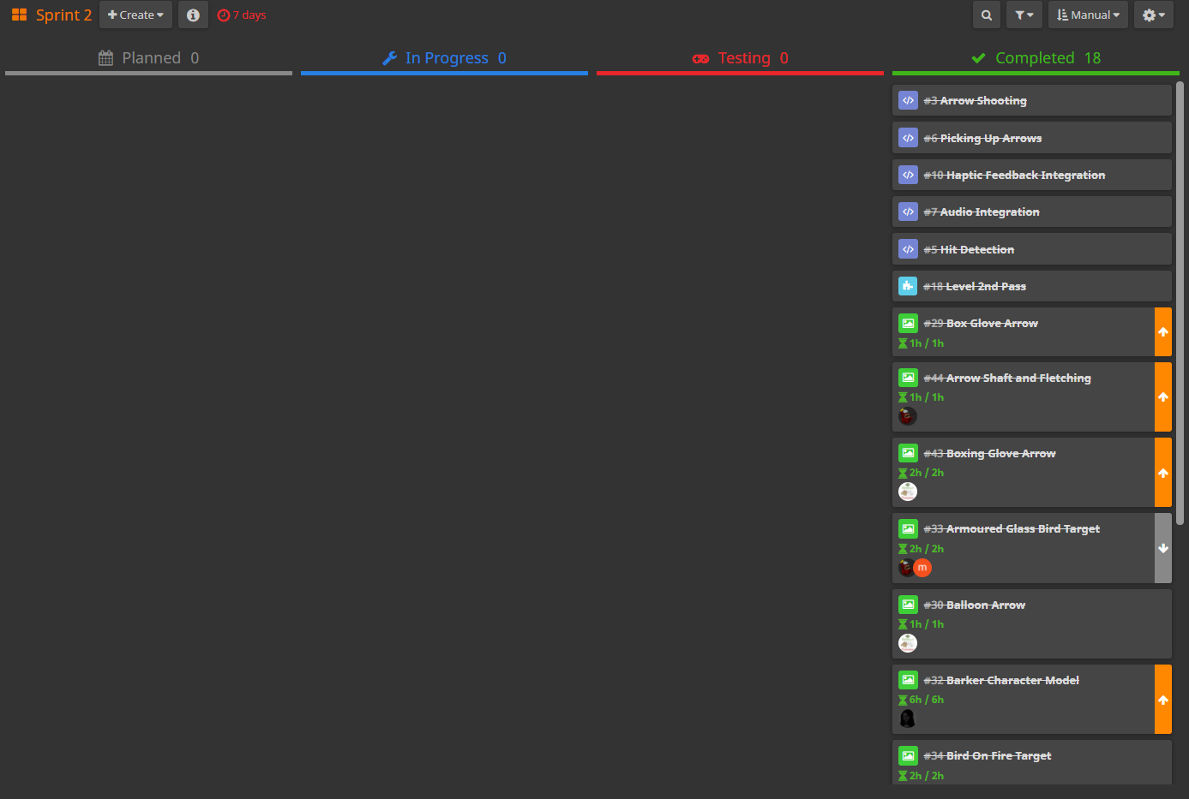**Sprints Screenshots**

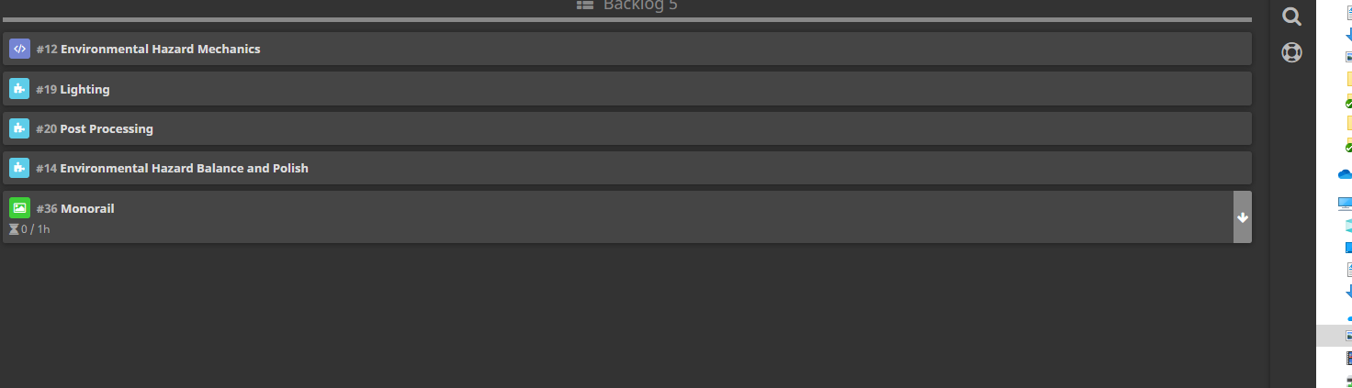**Backlog Screenshots**